Operating System Migration

🌟 Definition
# Source: AI Source: Provided by: [Data Path: Persons Table -> ID Column: 1, Name_En Column: Motasem Essam] -> From: [ChatGPT] on [6/7/2026]
Operating System Migration is the process of moving an application from one operating system to another while maintaining its functionality.
The application may need modifications to work correctly on the new operating system because different operating systems have different:
- File systems
- Commands
- APIs
- Security models
- Libraries
- Runtime environments

🎯 Purpose
# Source: AI Source: Provided by: [Data Path: Persons Table -> ID Column: 1, Name_En Column: Motasem Essam] -> From: [ChatGPT] on [6/7/2026]
OS migration is performed to:
- Reduce licensing costs
- Improve performance
- Improve security
- Support cloud environments
- Modernize infrastructure
- Eliminate dependency on outdated operating systems

🧠 Simple Definition
# Source: AI Source: Provided by: [Data Path: Persons Table -> ID Column: 1, Name_En Column: Motasem Essam] -> From: [ChatGPT] on [6/7/2026]
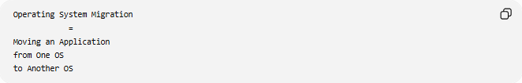
Operating System Migration
=
Moving an Application
from One OS
to Another OS

📚 What is an Operating System?
An operating system manages computer hardware and software resources.
Common operating systems:
- Microsoft Windows
- Linux
- macOS
- Ubuntu
- Red Hat Enterprise Linux

🔍 Common OS Migration Examples

1️⃣ Windows → Linux
# Source: AI Source: Provided by: [Data Path: Persons Table -> ID Column: 1, Name_En Column: Motasem Essam] -> From: [ChatGPT] on [6/7/2026]
Before
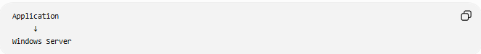
Application
↓
Windows Server

After
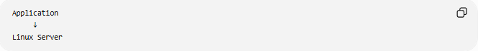
Application
↓
Linux Server

Benefits:
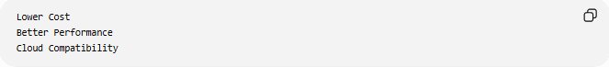
Lower Cost
Better Performance
Cloud Compatibility

2️⃣ Linux → Windows
# Source: AI Source: Provided by: [Data Path: Persons Table -> ID Column: 1, Name_En Column: Motasem Essam] -> From: [ChatGPT] on [6/7/2026]
Before
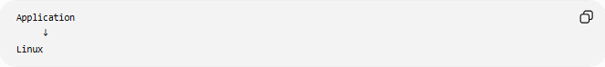
Application
↓
Linux

After
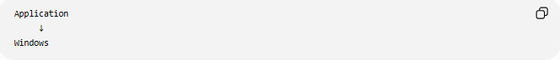
Application
↓
Windows

Reasons:
Business Requirements
Software Compatibility

3️⃣ Legacy Windows → New Windows Version
# Source: AI Source: Provided by: [Data Path: Persons Table -> ID Column: 1, Name_En Column: Motasem Essam] -> From: [ChatGPT] on [6/7/2026]
Before
Windows Server 2012

After
Windows Server 2025

Purpose:
Security Updates
Vendor Support

4️⃣ On-Prem Linux → Cloud Linux
# Source: AI Source: Provided by: [Data Path: Persons Table -> ID Column: 1, Name_En Column: Motasem Essam] -> From: [ChatGPT] on [6/7/2026]
Before
Local Linux Server

After
Cloud Linux Instance

Often part of cloud migration projects.

🛠️ Real-World Example
# Source: AI Source: Provided by: [Data Path: Persons Table -> ID Column: 1, Name_En Column: Motasem Essam] -> From: [ChatGPT] on [6/7/2026]
Before Migration
A PHP application running on:
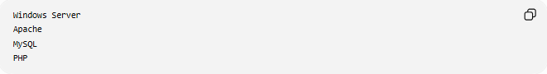
Windows Server
Apache
MySQL
PHP
Problems:
High Licensing Cost
Limited Automation

Migration
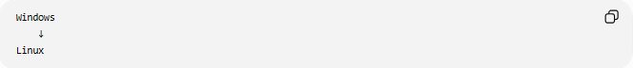
Windows
↓
Linux

After Migration
Linux
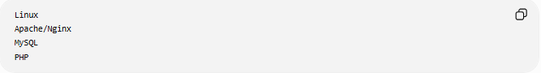
Apache/Nginx
MySQL
PHP
Benefits:
Lower Cost
Better Server Performance

🔄 OS Migration Lifecycle
# Source: AI Source: Provided by: [Data Path: Persons Table -> ID Column: 1, Name_En Column: Motasem Essam] -> From: [ChatGPT] on [6/7/2026]
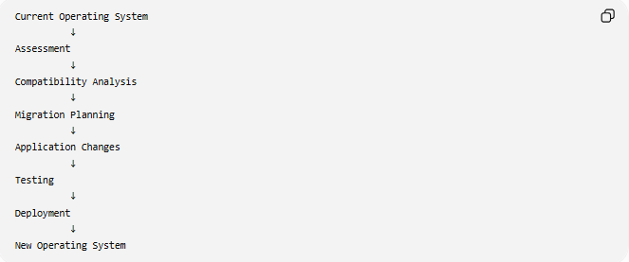
Current Operating System
↓
Assessment
↓
Compatibility Analysis
↓
Migration Planning
↓
Application Changes
↓
Testing
↓
Deployment
↓
New Operating System

📦 Components That May Need Changes
# Source: AI Source: Provided by: [Data Path: Persons Table -> ID Column: 1, Name_En Column: Motasem Essam] -> From: [ChatGPT] on [6/7/2026]
File Paths
Windows
C:\Projects\App

Linux
/var/www/app

Applications may need path updates.

Commands
Windows
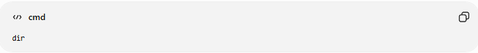
dir

Linux

ls

Scripts often require modification.

File System Behavior
Windows
File.txt
Equals
file.txt
(case-insensitive)

Linux
File.txt
and
file.txt
are different files.

Service Management
Windows
Windows Services

Linux
systemd

Permissions
Windows
NTFS Permissions

Linux
chmod
chown

🌍 Example Migration
# Source: AI Source: Provided by: [Data Path: Persons Table -> ID Column: 1, Name_En Column: Motasem Essam] -> From: [ChatGPT] on [6/7/2026]
Before
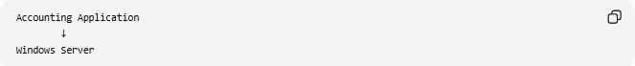
Accounting Application
↓
Windows Server

Migration
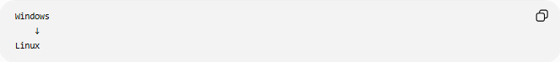
Windows
↓
Linux

After

Accounting Application
↓
Linux Server

Changes:
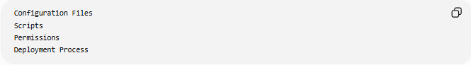
Configuration Files
Scripts
Permissions
Deployment Process

⚠️ Common Challenges
# Source: AI Source: Provided by: [Data Path: Persons Table -> ID Column: 1, Name_En Column: Motasem Essam] -> From: [ChatGPT] on [6/7/2026]
OS-Specific Code
Applications may use:
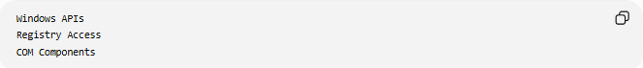
Windows APIs
Registry Access
COM Components
that do not exist on Linux.

File Path Differences
Different path formats may break code.

Third-Party Software
Some software may not be available on the target OS.

Permissions
User and file permissions work differently.

Testing Effort
Applications must be thoroughly tested.

✅ Benefits
# Source: AI Source: Provided by: [Data Path: Persons Table -> ID Column: 1, Name_En Column: Motasem Essam] -> From: [ChatGPT] on [6/7/2026]
Lower Licensing Costs
Linux distributions are often less expensive than commercial operating systems.

Better Performance
Some workloads perform better on Linux servers.

Improved Security
Modern operating systems provide enhanced security features.

Cloud Compatibility
Most cloud environments are optimized for Linux.

Long-Term Support
New operating systems receive:
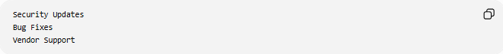
Security Updates
Bug Fixes
Vendor Support

📊 OS Migration vs Platform Migration
# Source: AI Source: Provided by: [Data Path: Persons Table -> ID Column: 1, Name_En Column: Motasem Essam] -> From: [ChatGPT] on [6/7/2026]
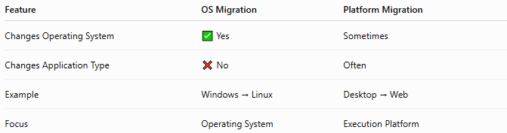
Feature | OS Migration | Platform Migration
Changes Operating System | ✅ Yes | Sometimes
Changes Application Type | ❌ No | Often
Example | Windows → Linux | Desktop → Web
Focus | Operating System | Execution Platform

OS Migration Example
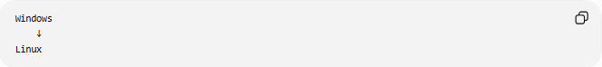
Windows
↓
Linux

Platform Migration Example
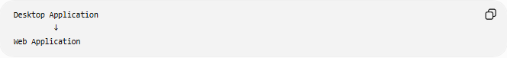
Desktop Application
↓
Web Application

🛠️ Common Technologies Used
# Source: AI Source: Provided by: [Data Path: Persons Table -> ID Column: 1, Name_En Column: Motasem Essam] -> From: [ChatGPT] on [6/7/2026]
Operating Systems
- Microsoft Windows
- Linux
- Ubuntu
- Red Hat Enterprise Linux
- macOS
Virtualization & Containers
- Docker
- VMware

🧠 Simple Analogy
# Source: AI Source: Provided by: [Data Path: Persons Table -> ID Column: 1, Name_En Column: Motasem Essam] -> From: [ChatGPT] on [6/7/2026]
Imagine moving a factory from one country to another.
Before
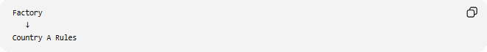
Factory
↓
Country A Rules

Migration
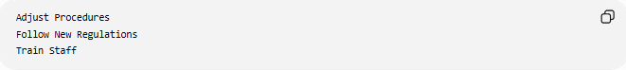
Adjust Procedures
Follow New Regulations
Train Staff

After
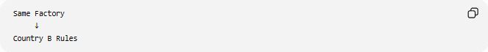
Same Factory
↓
Country B Rules
The factory still produces the same products, but it operates under a different environment.
Operating system migration works similarly:
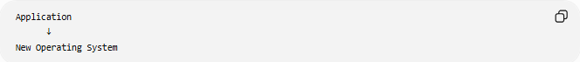
Application
↓
New Operating System
while keeping the application's core functionality intact.

🧭 Summary
# Source: AI Source: Provided by: [Data Path: Persons Table -> ID Column: 1, Name_En Column: Motasem Essam] -> From: [ChatGPT] on [6/7/2026]
Operating System Migration is a type of application migration where software is moved from one operating system to another, such as Windows → Linux, Linux → Windows, or older OS versions → newer OS versions. The migration often requires adjustments to file paths, permissions, scripts, services, and OS-specific APIs. The goal is to improve performance, security, cost efficiency, cloud compatibility, and long-term support while preserving application functionality.

